Following in the footsteps of Ramon Llull
CULTURAL TRIP TO MALLORCA
1-7 April 2016

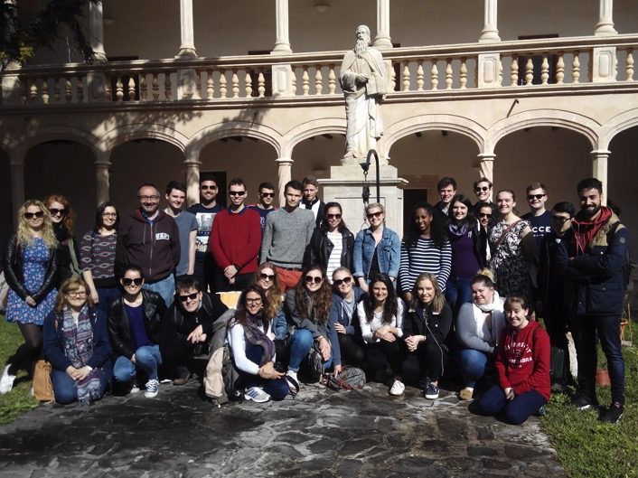

To coincide with the 700 anniversary of the death of the writer and philosopher Ramon Llull, Catalan language teachers from the universities of Durham and Newcastle, Liverpool and Cambridge organised a cultural trip to the island of Mallorca, where he was born.

The trip, which was entitled "Following in the footsteps of Ramon Llull", took place between 1 and 7 April, and consisted of three routes to the most important sites in order to understand the figure of Ramon Llull and a route to the Serra de Tramuntana, to raise awareness of the natural heritage and landscape of Mallorca.

The 32 participants, Catalan students from the above mentioned universities, discovered Mallorca with different eyes, beyond the image of sun and beaches that often spreads in the United Kingdom, and they practised their knowledge of Catalan thanks to the linguistic and cultural immersion.

Amongst the participants, there were six students currently taking paper “SP10: Introduction to Catalan Language and Culture” at the University of Cambridge.

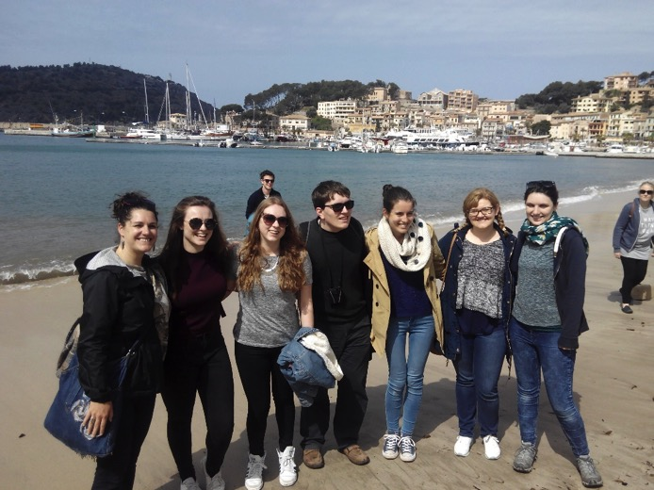

Various newspapers and media from the Balearic Islands echoed the news which served to publicize the work done by the Institut Ramon Llull and our job as Catalan lectors in the UK.

The organizers make a very positive assessment, and we would like to thank the institutions involved that have made things much easier and without which we could not have carried out this project.

Twitter interactions can be followed with the hashtag #TripLlullUK

In the following links you can read some of the news published recently in various media of the Balearic Islands.

Interview participants of the project "Following in the footsteps of Ramon Llull" Ona Mediterranean:
http://www.ivoox.com/entrevista-als-participants-del-projecte-seguint-les-passes-audios-p3_rf_11074650_1.html

dBalears news:
http://dbalears.cat/balears/2016/04/07/289874/mallorca-molt-mes-sol-platja.html

Última Hora:
https://twitter.com/CarmeCalduch/status/717419035227525121/photo/1

Carme Calduch
Catalan Lectora
Bye-Fellow in Fitzwilliam College
University of Cambridge

