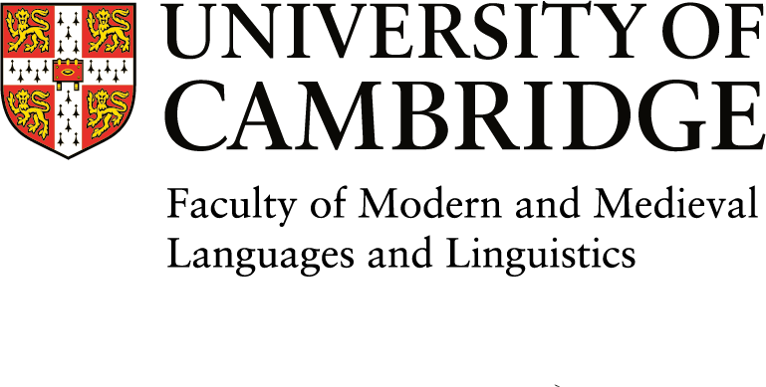
Sidgwick Avenue
Cambridge
CB3 9DA
Tel: (01223) 335038

VISITOR INFORMATION
1. | First name:
2. | Surname:
3. | Title:
4. | Email Address:
5. | Home address:
6. | Next of kin name and contact details: (in case of an emergency) | Name:  Relationship to visitor:  Telephone number:  Email address:
7. | Proposed mentor in Cambridge, if known
8. | Section within Faculty of proposed visit i.e. French, Linguistics
9. | Proposed visit start date:
10. | Proposed visit end date:
11. | Nationality:
12. | Is English your native language? (if not, proof of competency in English may be required. (IELTS/TOEFL/CAE/CPE))
13. | Visa required:
14. | Date of birth:
15. | Description of visiting status: | Visiting Scholar
16. | Funding details of visit: (e.g. Current employer(sabbatical salary), self-financed, grant)

17. | Current Employer: If applicable.  (Please state full address)
18. | Details of contact at your Employer: (eg your supervisor or line manager. They will be asked to sign the Visitor Letter, if application is successful) | Name:  Position:  Address:  China  Email:

Please provide the following documentation along with this form:
- A full CV
- A short outline of your proposed research
- Two academic references

Note that there are fees to pay for Visiting Scholars. These are £90 per week if visiting for less than one term, £720 per term, or £2400 for a full academic year, plus VAT.
More information on Visiting Scholars, can be found on the Faculty website here:
https://www.mmll.cam.ac.uk/faculty/academic-visitors

