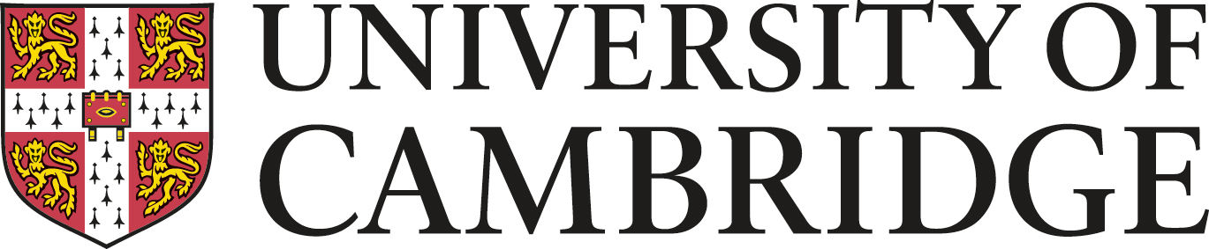
Bursary Request Form for CamMACT Conference on April 3rd 2017
Modern and Medieval Languages
CamMACT
- Please submit requests for bursaries by using this form. We will confirm bursaries within 14 days of receipt of the request
- We welcome applications from teachers at state schools.
- The conference itself, including a light lunch, is free. Bursaries are in place to help with travel expenses.
- We will allocate bursaries per school, allowing a maximum of two bursaries per school at discretion.
- There is a maximum of £150 per bursary.
- Please make your travel arrangements using the cheapest possible options. We will not be able to accept receipts for 1st class travel, for example.
- Money will be reimbursed once we have received your claim form after the conference. These will be sent to all who have been given a bursary.
- If you have any questions prior to submitting this request form, please contact Sofia Ropek-Hewson, Vice-President of CamMACT, at sar80@cam.ac.uk
  - School Details
School Name:
School Address:
School Telephone Number:
  - Staff Member Contact Details
Name:
Job title/position:
Email address:
Telephone number:
  - Estimated travel expenses

Please return the completed form to Sofia Ropek-Hewson at sar80@cam.ac.uk

