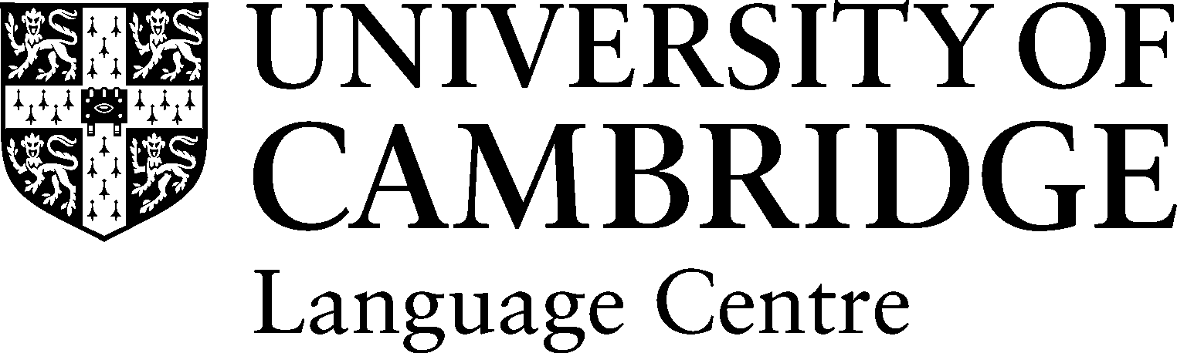The Language Centre
Faculty of Modern & Medieval Languages
Faculty of Asian and Middle Eastern Studies

Language Ambassador Application form 2017-18

MML and AMES Undergraduate Students

Name: |  | Email: | xxxx@cam.ac.uk
Home town: |  | Cambridge college:
Home county (or country if not UK): |  | Year of study: | 1st / 2nd / final
Type of secondary school attended | Independent or state school to age 16 or 18 / Independent or state school 16-18
Tripos &  Tripos languages | MML / AMES / MML & AMES | Specify language & whether post A level or ab initio | Specify language & whether post A level or ab initio
Other languages studied at school | Specify language (if not mentioned above) & level e.g. GCSE/A level | Specify language (if not mentioned above) &  level e.g. GCSE/A level | Specify language (if not mentioned above) &  level e.g. GCSE/A level
Mother tongue(s) & family / other language(s): | Mother tongue (s) | Other language spoken (not already mentioned above) | Other language spoken (not already mentioned above)
Year abroad destination(s). Or intentions if 1st/2nd year student) | Specify city/country  & study/work etc | Specify city/country & study/work etc | Specify city/country; study/work etc

I would like to be a Language Ambassador because:

I think I would be a good Language Ambassador because:

How to apply: Send this application form and a brief CV by email to outreach@mml.cam.ac.uk.

N.B. Paper copies can be submitted to the AMES and MML Faculty Offices.

