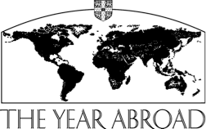

MODERN AND MEDIEVAL LANGUAGES TRIPOS PART II

CERTIFICATE OF ATTENDANCE

YEAR ABROAD 2017/2018

Name of Student .......................................... Date ........................................................

College ……………………………………..

Country (or countries) concerned

...................................................................................................................................................

Name(s) of institution(s)/employer(s)
...................................................................................................................................................

...................................................................................................................................................

Title of course(s)/job(s)

...................................................................................................................................................

...................................................................................................................................................

Start and finish dates .................................................................................................................

Signature(s) and/or stamp(s) of relevant authorities certifying completion or attach
a separate certificate or letter.

……………………………………….

……………………………………….

This certificate, together with your completed Year Abroad Report Form, must be handed in to the Year Abroad Office, Faculty of Modern and Medieval Languages, Sidgwick Avenue, Cambridge, CB3 9DA, by the second Friday of the Full Michaelmas Term.

Copies should also be sent to your College Director of Studies.

